Day in the Life of the Hudson River 10/13/22
Chelsea Yacht Club, Wappingers Falls, NY
RIVER MILE: 65
Salt Front: ~ RM76
Wappingers Jr. High School– Rosellen Hardt
22 students & 5 adults
Latitude 41.553508 N & Longitude – 73.97024 W
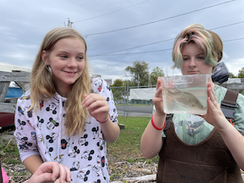 | 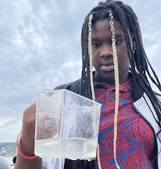 | 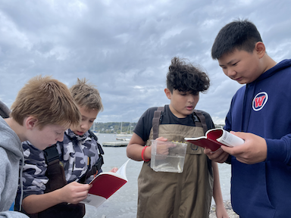

Location: Chelsea Boat Launch, Wappinger Falls, Dutchess County, NY
Area: Rocky, sandy beach adjacent to the dock.
Sampling Site: Pier with beach area, wood bulkhead, grassy, parking lot, shoreline covered in vegetation, riprap shoreline, concrete docking in area.
Surrounding Land Uses: 25% Urban/Residential, 15% Forested, 10% Beach, 50% Industrial/Commercial
Shoreline: 50% Muddy; 50% Rocky
River Bottom: Rocky
Water: NR
Plants in the Water: None
*NR = Not read/recorded
ITEM |  | Time |  | Reading |  |  |  | Comments
Physical
Air Temperature- |  | 1:04 PM |  | 18.3°C |  |  | 65°F
Wind Speed: |  | 1:04 PM |  | Anemometer  Not working |  |  | Beaufort  2 mph from chart | Direction  NE
Weather today |  | 9:15 AM |  | >75% cloud cover |  |  | No Rain
Weather the past 3 days: |  | Chilly and Rainy
Tides- |  | Time |  | Rising, Falling, Unchanged |  |  | Water Height (cm)
 |  | 9:30 AM  10:15 AM  10:45 AM |  | Rising  Rising |  |  | NR
Current- |  | Time |  | Cm/sec |  | Knots | North/South | Ebb/Flood/Still
 |  | 10:33 AM  11:44 AM  12:58 PM  1:50 PM |  | 26.22  23.44  29.0  12.5 |  | NR | NR | Ebb
Water Temperature- NR
Turbidity- Long Sight Tube (120 cm) |  | 11:10 AM |  | 40.3 cm
Chemical
Salinity-LR Quantabs |  | 11:00 AM |  | NR
Standardized Salinity – LR Quantabs |  | 1:00 PM |  | 52 ppm
DO – NR – missing a stopper in kit |  | Time |  | Temp |  |  | ppm DO | % saturation
pH – Color Match Kit |  | 9:40 AM |  | 7.5
Nitrates- NR
Phosphates- NR
Alkalinity- NR
Biological-
Fish – Seine |  | Number |  | Name |  |  | Length of longest | Length of smallest
9:30 AM- 12:00 PM  4 seines |  | 11  2  7  2  8 |  | Herring spp.  Spottail Shiner  Banded Killifish  Atlantic Silverside  White Perch |  |  | 5.5 cm  8 cm  7 cm  6 cm  14 cm | 4.5 cm  8 cm  6.5 cm  6 cm  10 cm
Fish Totals |  | TOTAL: 30 |  | Diversity: 5
Macroinvertebrates |  | Number |  | Name |  |  | Length of longest | Length of smallest
 |  | 5 |  | Blue Crab  (1M, 2F, 2 unidentified) |  |  | 4.5 cm | 2 cm
Macroinvertebrate Totals |  | TOTAL: 5 |  | Diversity: 1
Sediment Core –NR
Length | H2S smell |  | Oxid Top |  | Oil |  | Grain Size | Other Features
Boats- NR
 | Time |  | Name |  | Color |  | North/Southbound | Light/Loaded
Commercial
Recreational

